AFFORDABLE ASSISTED LIVING COALITION LAUNCHES
“LET’S GET VACCINATED” CAMPAIGN

Campaign Encourages Supportive Living Staff to Vaccinate

For Immediate Release Contact: Bill Bradley
February 1, 2021 916-213-5230
bill@me-comm.com

SPRINGFIELD, Ill. – The Affordable Assisted Living Coalition (AALC) today launched its “Let’s Get Vaccinated - Together We Can Do It” campaign to urge Illinois’ Supportive Living staff members to get vaccinated for COVID-19. Supportive Living residents are seniors and people with underlying health conditions, which make them some of the most at-risk populations in the state. Ensuring that those who work with these populations are vaccinated is a step in the right direction in keeping them safe and healthy.

“Illinois has more than 150 Supportive Living Communities serving seniors and persons with disabilities, so it’s important that staff members get vaccinated as quickly as possible to ensure that all of our residents have peace of mind knowing they are being taken care of in the safest environment possible," said AALC Executive Director Karin Zosel. “Our goal with the Let’s Get Vaccinated campaign is to get one hundred percent of Supportive Living employees across the state vaccinated so we can move forward.”

The Let’s Get Vaccinated campaign is designed to be informative, fun and competitive. To educate individuals, AALC has teamed up with Medication Management Partners to host several webinars over the coming months addressing how to overcome staff hesitancy toward vaccinations, provide helpful resources, and answer any questions and concerns from members regarding the COVID-19 vaccine.

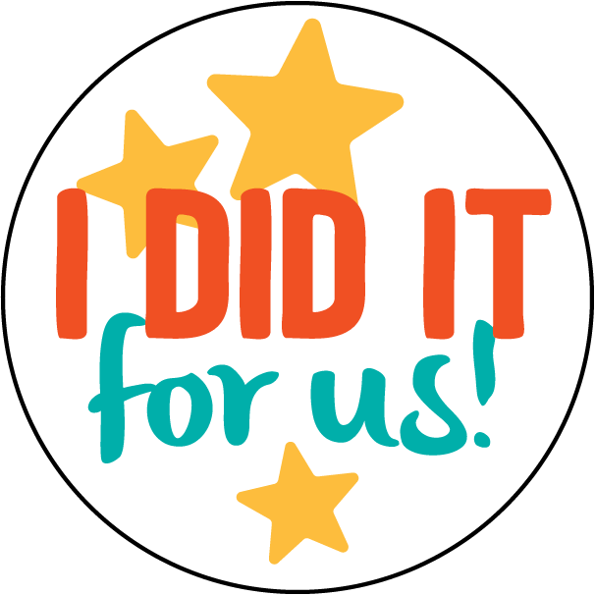
To make the campaign fun and competitive, AALC designed an I DID IT for Us! button. These colorful buttons can be worn by staff during work hours to showcase the fact they have been vaccinated, and jumpstart conversations regarding the importance of getting vaccinated when people ask what the button means. It may also encourage staff members who have not been vaccinated to schedule their appointment. Additionally, posters announcing the campaign urge staff members to get vaccinated by offering cash prizes to vaccinated staff members throughout the campaign.

Communities and staff members qualify for prizes by posting photos of staff on social media following their vaccinations and wearing the I DID IT for us buttons. Communities will use the hashtags #IDIDITFORUS and #LETSGETVACCINATED to track their progress. When the campaign ends, AALC will offer group prizes to communities who demonstrate
a high rate of vaccinations among staff.

The campaign runs from February 1 through April 30, 2021. Visit www.aalcillinois.org for more information.

###

